dopey2 description

This document is not ready.

data object

data = dopey.load(file_name)

dopey sorts data it recognizes into arrays, accessible as attributes (ndarray):

data.intensity, data.axis0, data.axis1, …

Parameters used for data acquisition are sorted into arrays, accessible as attributes (ndarrays):

data.parameter0, data.parameter1, …

Labels for .intensity, .axis#, and .parameter# are accessible as attributes (str):

data.intensity_label, data.axis#_label, and data.parameter#_label

dopey extracts meta data from the file that are also accessible as attributes.

Example:

Loading a regular ARPES cut returns a data object like this:

data.info

intensity Array shape = (400, 400) counts/s
axis0 Array shape = (400,) ordinate range
axis1 Array shape = (400,) Kinetic energy (eV)
Ek Scalar 18.7036
Ep Scalar 20.0
-
file_name String id8.xy
experiment Dictionary
parameters List len = 0
data_type String ccd_2d
intensity_label String counts/s
axis0_label String ordinate range
axis1_label String Kinetic energy (eV)
Spectrum_ID String 8
Analysis_Method String UPS
Analyzer String PhoibosCCD
Lens_Mode String WideAngleMode
Scan_Mode String SnapshotFAT
Comment String

The data can be visualized using dopey’s plot() method:

dopey.plot(data)
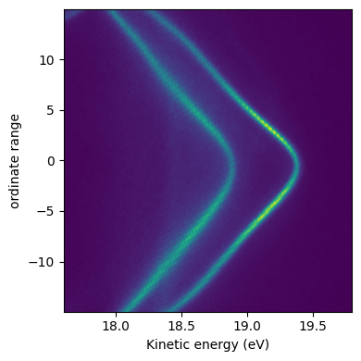
or, you can plot it manually, e.g.:

_, ax = matplotlib.pyplot.subplots()
extent = [data.axis1[0], data.axis1[-1], data.axis0[-1], data.axis0[0]]
ax.imshow(data.intensity, extent = extent, aspect = "auto")
ax.invert_yaxis()
ax.set_xlabel(data.axis1_label)
ax.set_ylabel(data.axis0_label)

Not recognizable data

If the collected data is not recognized by dopey it will still be loaded. All values are accessible from the following attributes

.raw_experiment
.raw_parameter_values
.raw_cycles
.raw_curves
.raw_steps
.raw_non_energy_ordinate
.raw_column1
.raw_column2

which are all arrays which can then be sorted manually.

General methods

.plot(data, ax, **kwargs)

The data argument is e.g. the output from .load()(dopey identifies what type of data it is and generates a plot). Depending on the data type, data dimensionality, etc., there are various keyword arguments available. Pass help = True to see what they are. The ax argument is optional and should be a of type matplotlib.axes._axes.Axes if passed.

See dopey2_plot_description for more info.

Example, spin edc:

data3 = dopey.load(file.xy)

Data type:
spin_edc
Data, axes, and parameters:
intensity counts/s shape=(8, 66)
axis0 Kinetic energy (eV) shape=(66,)
parameter0 NegativePolarity shape=(8,)

dopey.plot(data3)

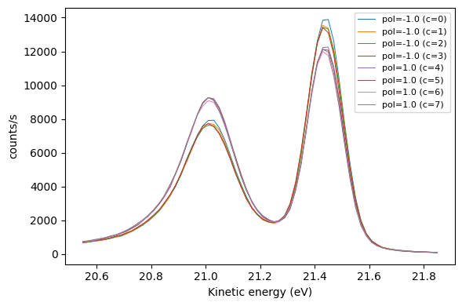

data3s = dopey.asymmetry(data3)
dopey.plot(data3s, asymmetry = True)

